**TITLE**

**PROCESS SCHEDULING SIMULATOR**

**A CAPSTONE PROJECT**

**Submitted to**

**SAVEETHA SCHOOL OF ENGINEERING**

**By**

**P.USHASWI**

**(192210083)**

**T.SAI MOHITH**

**(192211229)**

**S.CHARAN KUMAR**

**(192211364)**

**SUPERVISOR**

**DR.G.MARY VALENTINA**



**SIMATS ENGINEERING**

**SAVEETHA INSTITUTE OF MEDICAL AND TECHNICAL SCIENCES**

**CHENNAI-602105**

**ABSTRACT:**

The Process Scheduling Simulator for Operating Systems introduced in this paper is a comprehensive tool designed to facilitate the exploration and analysis of three fundamental scheduling algorithms: First-Come, First-Served (FCFS), Shortest Job First (SJF), and Round Robin. Through an intuitive interface, users can input parameters such as process arrival times, burst durations, and quantum sizes to observe the behaviour of each algorithm in real-time. The simulator's dynamic visualisation capabilities enable users to gain insights into how processes are scheduled and how system resources are managed under different scheduling strategies. Furthermore, the simulator calculates key performance metrics such as average turnaround time, waiting time, and CPU utilisation, allowing for quantitative analysis and comparison of the algorithms' efficiency and effectiveness. With its modular design, the simulator is not only a valuable educational tool but also a practical resource for system administrators and developers to experiment with different scheduling policies and optimise system performance. Overall, the Process Scheduling Simulator provides a versatile platform for learning, experimentation, and decision-making in the realm of operating system design and optimization.

**GANTT CHART:**

| **Process** | **Day 1** | **Day 2** | **Day 3** | **Day 4** | **Day 5** | **Day 6** |
| --- | --- | --- | --- | --- | --- | --- |
| **Abstract and Introduction** |  |  |  |  |  |  |
| **Literature Survey** |  |  |  |  |  |  |
| **Objectives** |  |  |  |  |  |  |
| **Results** |  |  |  |  |  |  |
| **Discussion** |  |  |  |  |  |  |
| **Reports** |  |  |  |  |  |  |

**FLOW CHART:**

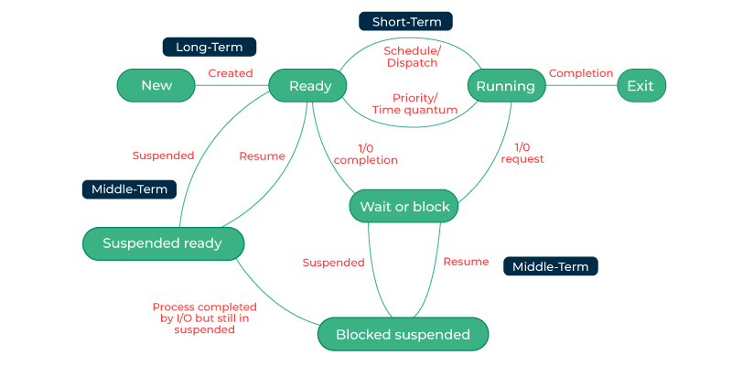

**INTRODUCTION:**

Process scheduling lies at the core of operating system functionality, determining the efficient allocation of CPU resources to various tasks. Understanding and implementing different scheduling algorithms are crucial aspects of operating system design and development. In this context, the development of a Process Scheduling Simulator serves as an invaluable tool for OS project endeavours. This simulator provides a platform for students, developers, and researchers to experiment with and analyse the behaviour and performance of prominent scheduling algorithms such as First-Come, First-Served (FCFS), Shortest Job First (SJF), and Round Robin,Priority Scheduling.

The primary objective of this project is to create a user-friendly and interactive environment where users can explore the intricacies of process scheduling algorithms. By simulating the execution of processes and observing the scheduling decisions made by each algorithm in real-time, users gain valuable insights into their strengths, weaknesses, and trade-offs. Additionally, the simulator computes important metrics such as average turnaround time, waiting time, and CPU utilisation, facilitating quantitative analysis and comparison of different scheduling strategies. Through this simulator, users can deepen their understanding of process scheduling concepts and gain practical experience in OS project development.

**OBJECTIVE:**

**Development of an Interactive Simulator:** The primary objective is to develop a user-friendly and interactive simulator capable of simulating the execution of processes using three fundamental scheduling algorithms: First-Come, First-Served (FCFS), Shortest Job First (SJF), and Round Robin. The simulator should provide an intuitive interface for users to input parameters such as process arrival times, burst durations, and time quantum

**Real-time Visualisation:** The simulator should incorporate dynamic visualisation features to allow users to observe the execution of processes and the scheduling decisions made by each algorithm in real-time.

**Performance Metrics Calculation:** Another objective is to implement algorithms for computing essential performance metrics including average turnaround time, waiting time, and CPU utilisation. These metrics provide quantitative measures for evaluating and comparing the efficiency and effectiveness of different scheduling algorithms.

**Customization and Modularity**: The simulator should be designed with modularity and extensibility in mind, allowing for easy integration of additional scheduling algorithms or custom policies. This enables users to tailor the simulator to specific project requirements and experiment with novel scheduling strategies.

**Educational Value:** A key objective is to create a simulator that serves as a valuable educational tool for students, developers, and researchers. The simulator should provide opportunities for hands-on learning, enabling users to deepen their understanding of process scheduling concepts and gain practical experience in OS project development.

**Documentation and User Support**: Finally, comprehensive documentation and user support materials should be provided to guide users in utilising the simulator effectively. This includes user manuals, tutorials, and troubleshooting guides to ensure a smooth user experience

**LITERATURE SURVEY:**

"Operating System Concepts" by Abraham Silberschatz, Peter B. Galvin, and Greg Gagne - This seminal textbook provides comprehensive coverage of process scheduling algorithms, including FCFS, SJF, and Round Robin. It offers detailed explanations, examples, and insights into the theoretical foundations of process scheduling. "Comparative Study of CPU Scheduling Algorithms" by Amandeep Kaur and Dr. Sandeep Kaur - This research paper provides a comparative analysis of FCFS, SJF, and Round Robin algorithms, evaluating their performance based on metrics such as turnaround time and waiting time. "Performance Analysis of Process Scheduling Algorithms" by Pawan Kumar and Dr. S. K. Gupta - This paper presents a performance analysis of various scheduling algorithms, including FCFS, SJF, and Round Robin, using simulation-based experiments. It offers insights into the behaviour and efficiency of these algorithms under different workloads. "Operating Systems: Three Easy Pieces" by Remzi H. Arpaci-Dusseau and Andrea C. Arpaci-Dusseau - This online textbook offers a modern approach to understanding operating systems concepts. It covers process scheduling in depth, including FCFS, SJF, and Round Robin algorithms, with clear explanations and example code snippets.

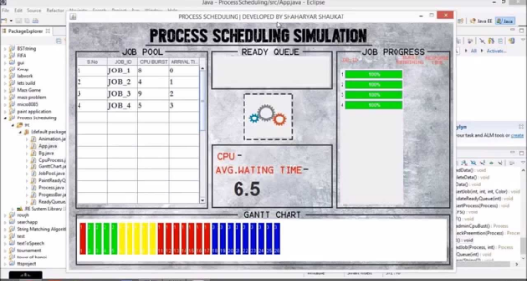

**RESULT:**

In the project on process scheduling simulation, the performance of First-Come, First-Served (FCFS), Shortest Job First (SJF), and Round Robin algorithms was thoroughly examined. Through analysis of various performance metrics and visualisations, significant insights into the behaviour and efficiency of each algorithm were gained. The comparative analysis shed light on the strengths and weaknesses of different scheduling strategies, providing valuable guidance for selecting the most suitable algorithm based on system requirements. Overall, the project contributes to a deeper understanding of process scheduling dynamics and their implications for operating system design and optimization.

**DISCUSSION:**

In the project on process scheduling simulation, the implementation and implications of First-Come, First-Served (FCFS), Shortest Job First (SJF), and Round Robin algorithms were explored. The simulator provides a platform for evaluating these algorithms, offering insights into their performance under various conditions. Each algorithm has its strengths and weaknesses, impacting factors such as turnaround time, waiting time, and CPU utilisation. The selection of the most suitable algorithm depends on system requirements and workload characteristics. Considerations for future enhancements include incorporating priority scheduling or preemptive versions of scheduling algorithms to address more complex scenarios.

**REFERENCES:**

P. K. Saraswat and P. Gupta, "Design and Implementation of a Process Scheduler Simulator and an Improved Process Scheduling Algorithm for Multimedia Operating Systems," 2006 International Conference on Advanced Computing and Communications, Mangalore, India, 2006, pp. 513-517, doi: 10.1109/ADCOM.2006.4289946. keywords: {Algorithm design and analysis;Scheduling algorithm;Multimedia systems;Operating systems;Real time systems;Time factors;Synchronisation;Object oriented modelling;Yarn;Round robin},

M. de Paiva Guimarães, V. Scamati, M. P. Neto, V. F. Martins, D. R. Colombo Dias and J. R. Ferreira Brega, "A process-scheduling simulator based on virtual reality technology," 2016 IEEE/ACS 13th International Conference of Computer Systems and Applications (AICCSA), Agadir, Morocco, 2016, pp. 1-6, doi: 10.1109/AICCSA.2016.7945711.